# Customer and supplier data application

## Home page after clicking home link

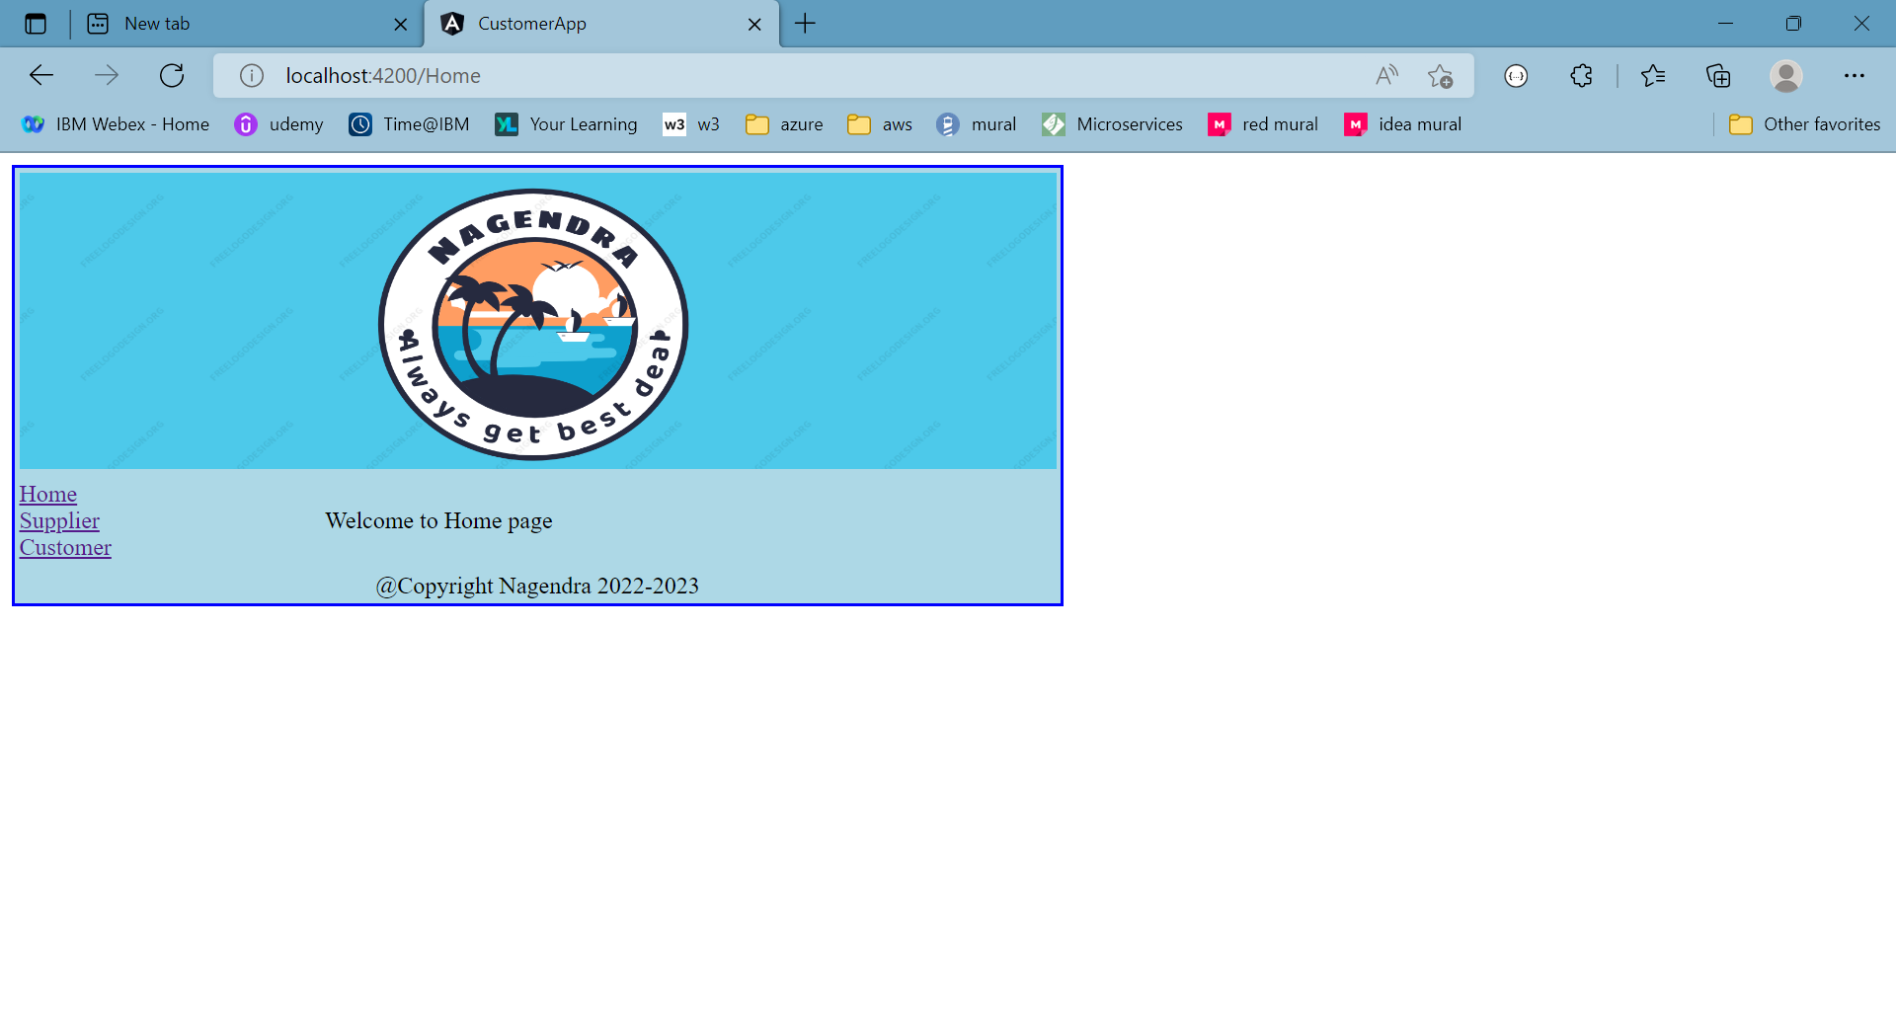

## After clicking on supplier link

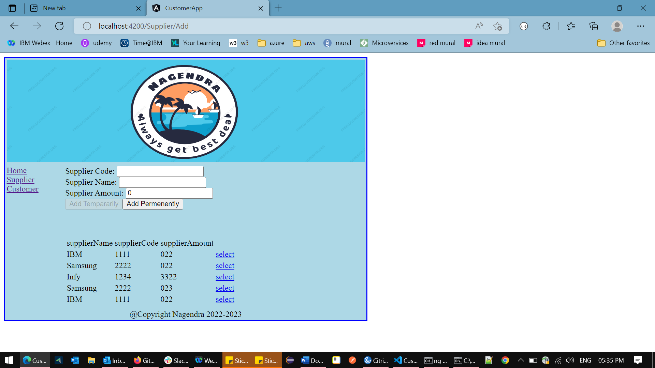

Enter supplier code as “12”, to get validation errors

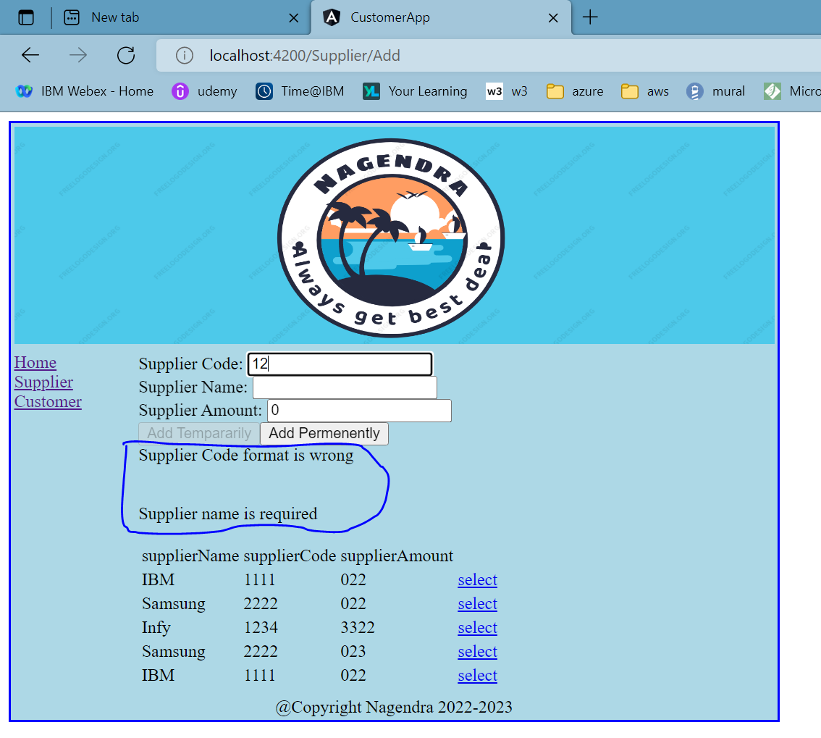

## Supplier code is required and name is required

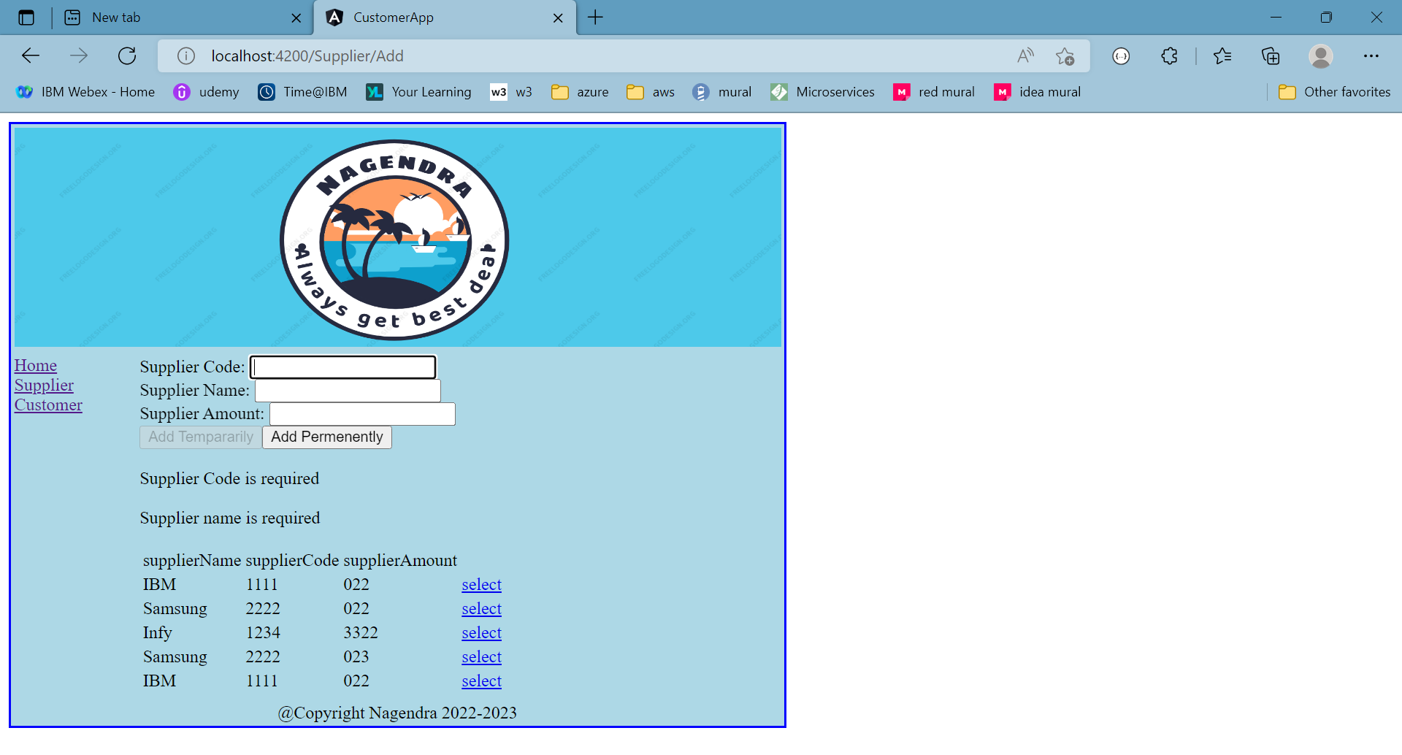

## Add tempararily

Enter 4 digits of code and some name with certain amount, click on Add temporarily button

This will temporarily add the details in browser memory and disappear if we refresh application.

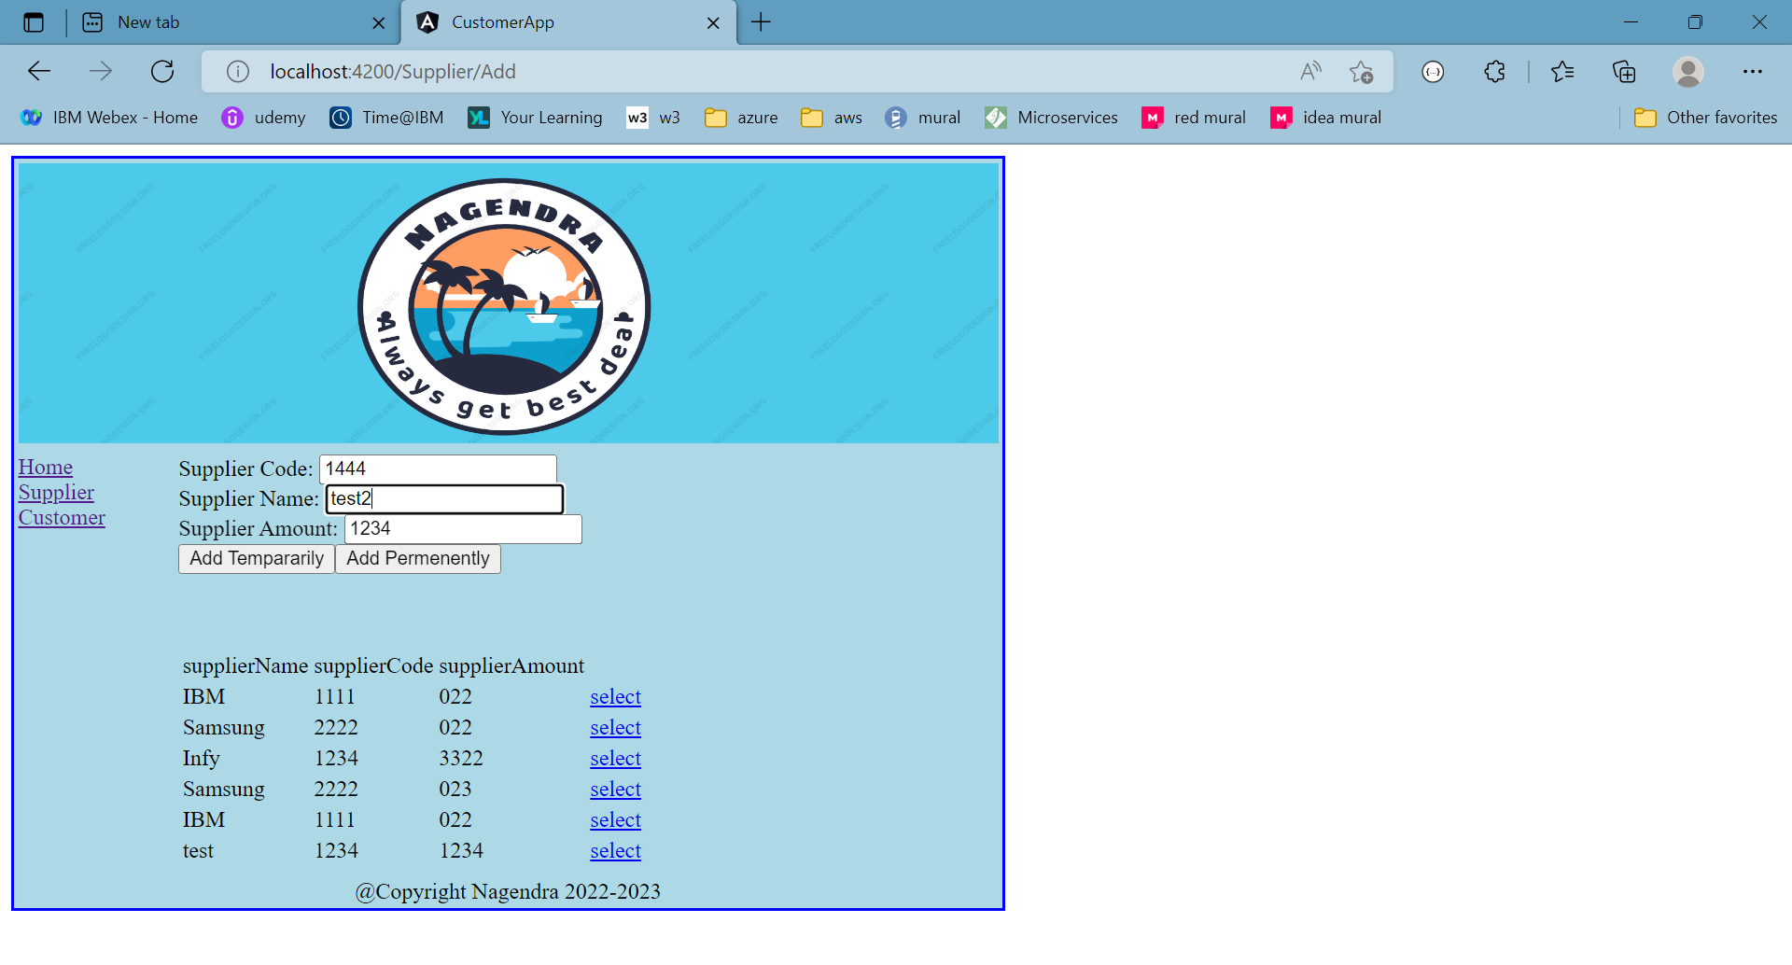

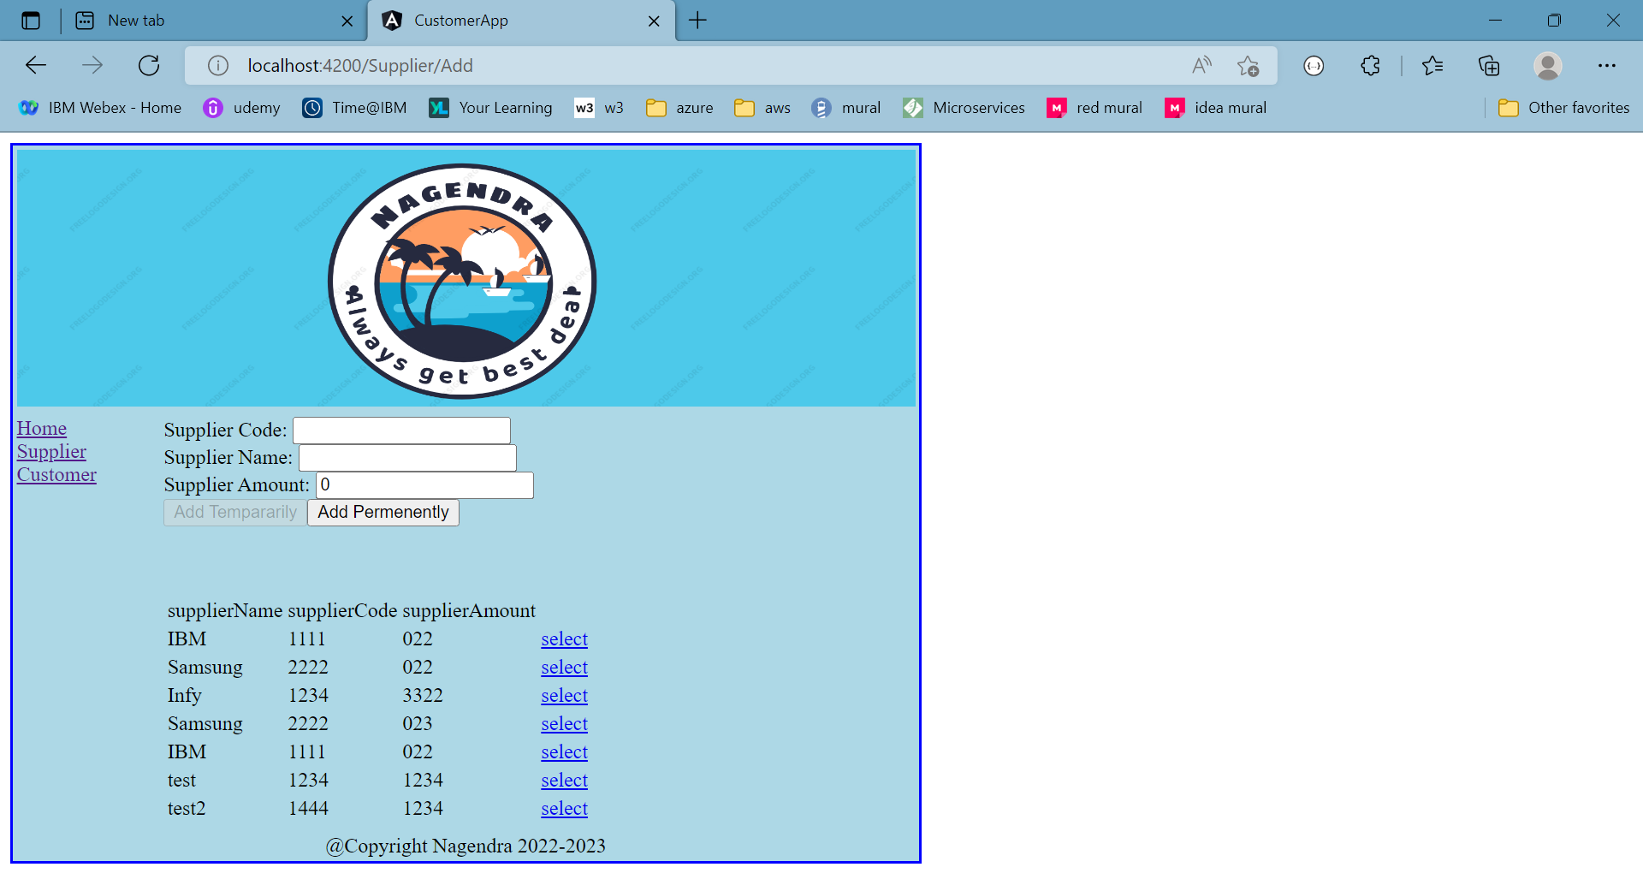

## Add permanently

Enter 4 digits of code and some name with certain amount, click on Add permanently button

This will permanently add the details in db.json file and retained even if we refresh application.

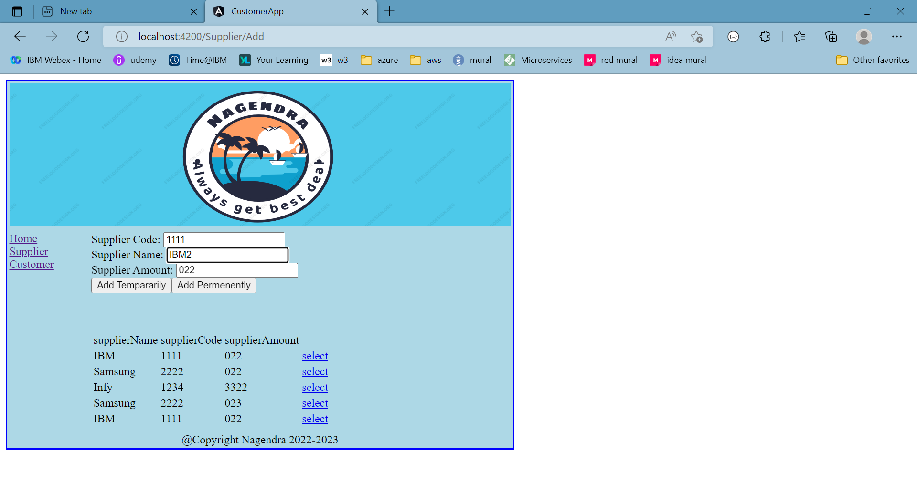

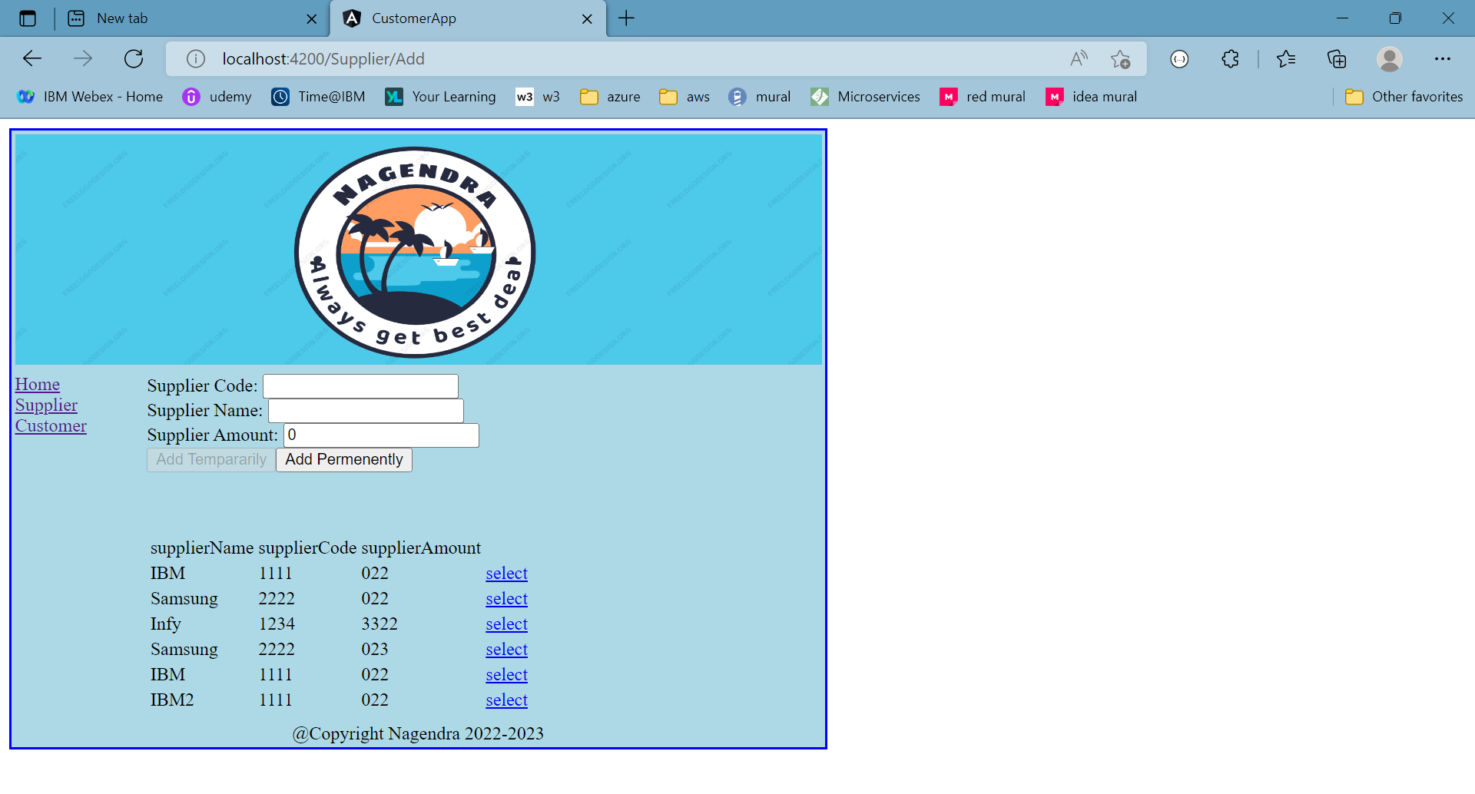

## Click on select link

If we click on select link against the row, respective row details are prepopulated in form so that user can edit and add again. This wont update existing row but adds new row

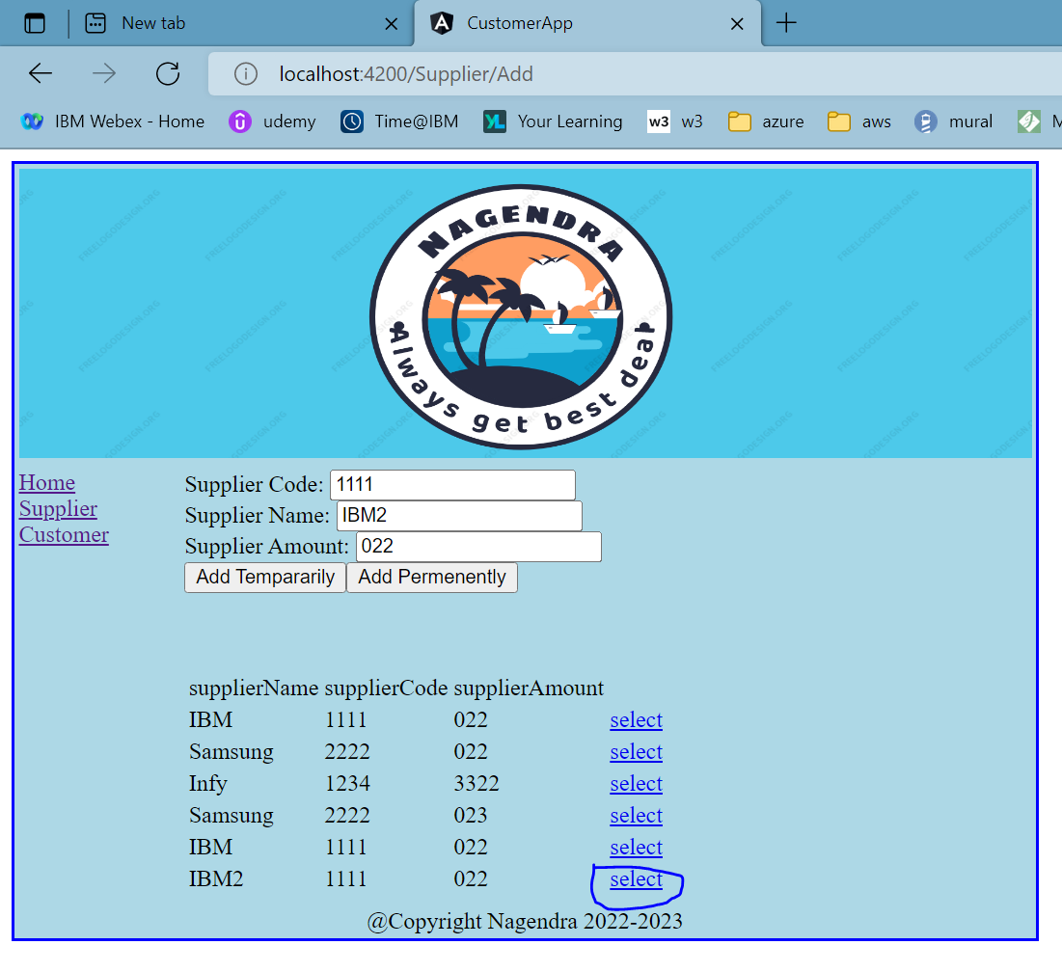

# Same functionalities replicated for customer link as well by using reusable UI component (grid-ui)

